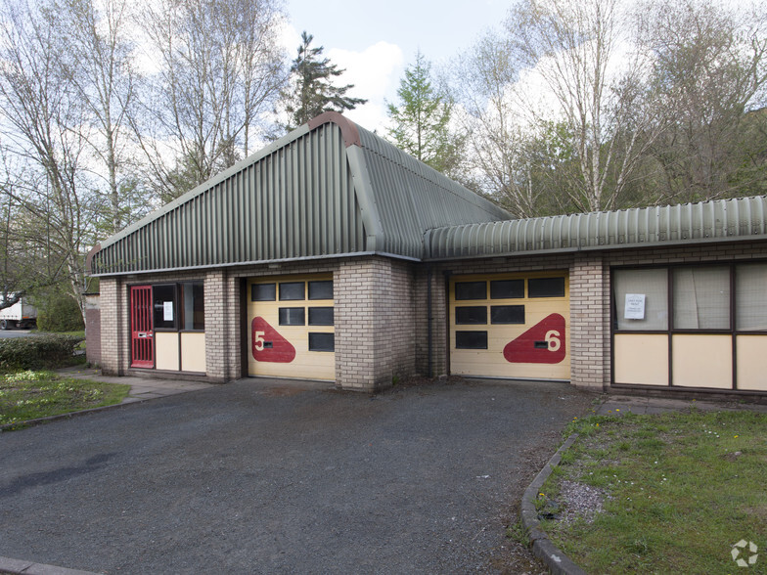
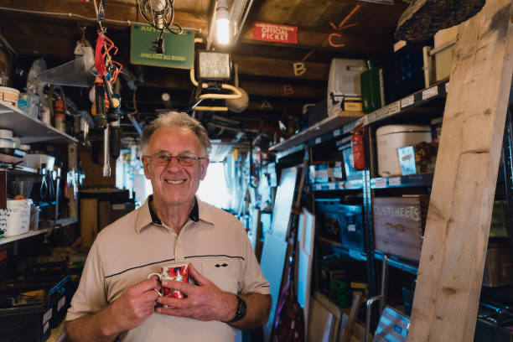
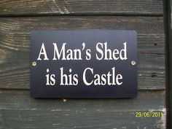
Men’s Shed
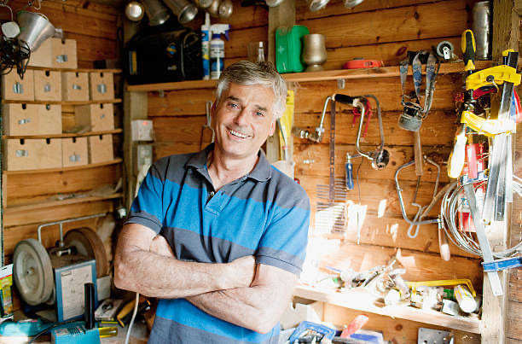

Grwp Ymarferol i Ddynion Llanfyllin

Practical Group for Men
Men’s Shed is a new way for men to discover new interests and hobbies as part of a group.  Mae ‘Men’s Shed’ yn ffordd newydd i ddynion ddarganfod diddordebau newydd fel rhan o grwp.  Want to share different skills and interests with other local men?  Eisiau lle i rannu sgiliau a diddordebau gyda dynion lleol eraill?  Diddordeb? Interested?  Dewch draw / Come along  Every Wednesday and Friday 10.00am – 3.00pm  Unit 3, Llanfyllin Enterprise Park, SY22 5DD  Am fwy o wybodaeth/ For further info.  Contact David on 07532 296457  Email: Llanfyllinmensshed@gmail.com |  | Busy in the workshop  Making bird boxes for the RSPB

