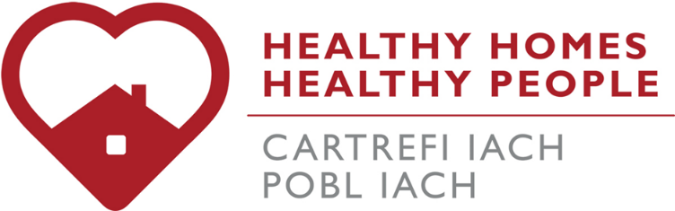

Healthy Homes, Healthy People works across Wales and the South-West of England supporting people to have:
- Warmer homes
- Safer homes
- Healthier homes
We do this by offering a range of advice, support and referral options tailored to the needs of the household. Healthy Homes, Healthy People is open to everyone, but some of the services we refer to have their own eligibility criteria.
Support we can offer includes:
- Energy: help and advice with understanding energy bills, support with fuel debt, tariff-switching, smart meters, savings and discounts (e.g., Warm Home Discount)
- Water: information, advice and support with tariff reductions and water meters
- Heating: support with applications to Nest, a Welsh Government-funded scheme, providing replacement boilers, central heating systems and insulation to qualifying households
- Income maximisation: support and signposting for benefit checks and council tax reduction applications
- Home adaptations: support accessing grab-rails, level access showers, stair lifts etc.
- Priority Service Register: free registration with gas, electricity and water providers for qualifying households
- Home safety measures: carbon monoxide awareness, smoke alarms and locking cooker valves - information and advice for all and devices for qualifying households
- Connection to the gas network: support to apply for gas connection vouchers where eligible
If you, or someone you know, is finding it hard to heat their home, please get in touch.
- hhhp@warmwales.org.uk
- Katrina (Lead Community Worker) – 07795 950 881
- Katie (Project Manager) - 07889 311 051
- www.warmwales.org.uk

