Aberystwyth Shop Mobility
Provided by

Telephone: 01970 617176

E-mail: shopmobility@caresociety.org.uk

Website: https:www.caresociety.org.uk/services/moility-scooter-hire-aberystwyth

The Care Society Shop
27 Chalybeate Street
Aberystwyth
Ceredigion
SY23 1HX

We hire out mobility scooters and wheelchairs to anyone who needs help getting around Aberystwyth.

Using shop mobility:

Mobility equipment is available for collection from our combined charity shop and Shopmobility centre at 27 Chalybeate Street, Aberystwyth from 10.00am-4.30pm, Monday to Saturday.

We have a range of wheelchairs and mobility scooters that are available for hire either by pre-booking or by dropping in to the shop on a first come first serve basis.

Equipment can also be collected from our designated meeting point at Aberystwyth Railway Station. This is available by advance booking only so if you would like to use this service please phone or drop into the shop to make arrangements.

Cost:

 | Electric Scooter | Wheelchair
Half Day | £6.50 | £3.50
Full Day | £13 | £6
Week | £65 | £30

If you wish to keep a piece of equipment beyond your initial loan then we ask you to call in to the shop or phone us to arrange an extension. Penalties will be incurred for late returns.

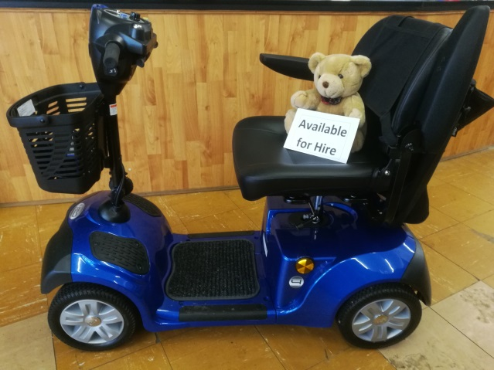

Siop Symudedd

Aberystwyth
Darperir gan

Ffôn: 01970 617176

E-bost: shopmobility@caresociety.org.uk

Gwefan:
https:www.caresociety.org.uk/services/moility-scooter-hire-aberystwyth

Siop Cymdeithas Gofal
27 Chalybeate Street
Aberystwyth
Ceredigion
SY23 1HX

Rhydym yn llogi ein sgwteri symudedd a chadeiriau olwyn I unrhyw un sydd angen cymorth I symud o gwmpas Aberystwyth.

Gan Ddefnyddio Shopmobility:

Cyfarpar symudol ar gael i’w gasglu gan ein canolfan siop elusen a shopmobility cyfunol yn 27 Stryd y Ffynnon Haearn, Aberystwyth rhwng 10.00yb – 4.30ph, o ddydd Llun i dydd Sadwrn.

Mae gennym amrywiaeth o gadeiriau olwyn a sgwteri symuddol sydd ar gael i’w llogi nail ai y cyn-archebu new drwy alw heibio i’r siop ar sail y cyntaf a wasanaethir ddod yn gyntaf.

Gall offer hefyd i’w gael ei gasglu oddi wrth ein man cyfarfod penodedig yng Ngorsaf Reilffordd Aberystwyth. Mae hwn ar gael drwy archebu ymlaen llaw yn unig, felly os hoffech ddefnyddio’r gwasanaeth hwn, ffoniwch new galwch i mewn i’r siop i wneud trefniadau.

Cost:

 | Sgwter Symudedd | Cadair Olwyn
Hanner diwrnod | £6.50 | £3.50
Diwrnod llawn | £13 | £6
Wythnos | £65 | £30

Os hoffech cadw’r offer dros yr amser gwreiddiol a cytunwyd, gofynnwyd i chi trefnu estyniad trwy galw yn y siop neu ffonio. Fe fydd cosb am unrhyw dychweliad hwyr.

