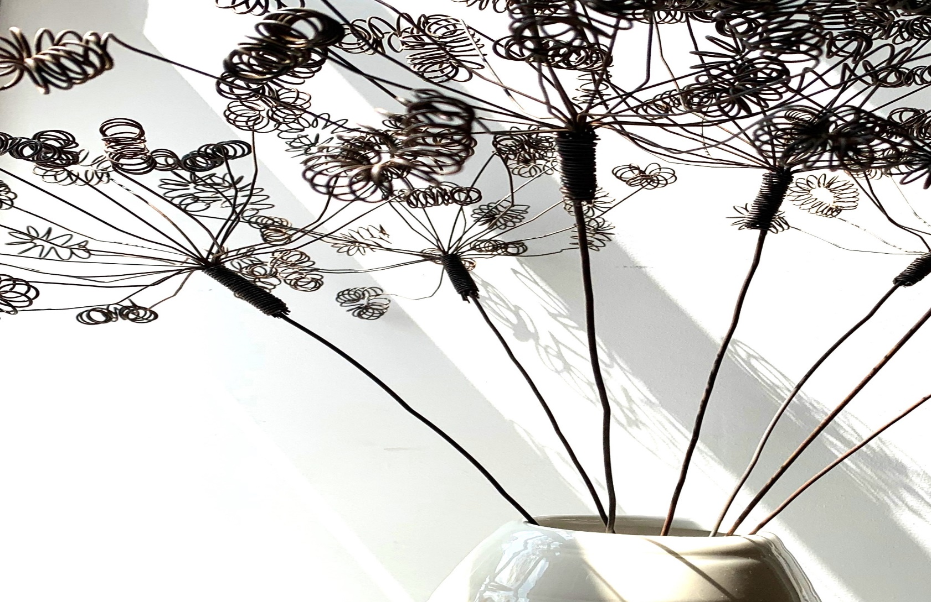FN99801-IMG05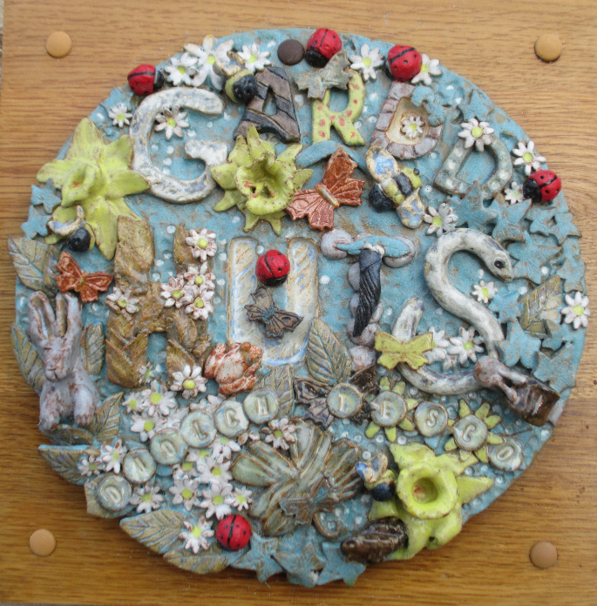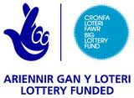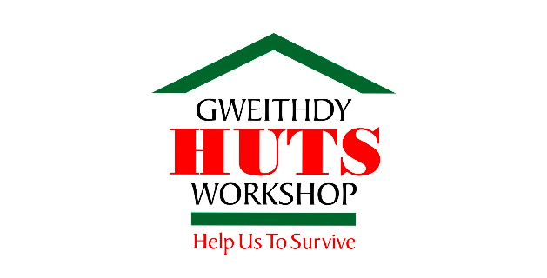FN99801-IMG08

Tel: 01239 710377

Email: [info@hutsworkshop.org](mailto:info@hutsworkshop.org)

[www.hutsworkshop.org](http://www.hutsworkshop.org)

**Registered Charity No: 1081648**

**Company No: 3874210**

**Call & Chat Service**

HUTS also offers a telephone Call & Chat support service.

Our aim is to provide individuals experiencing difficulties with their mental health the chance to have a casual confidential conversation on a regular basis in order to restore better mental health.

Our dedicated staff will answer your first call in or ring you back as soon as possible.

From that point onwards we will arrange with you, if you wish, to have beneficial, regular ongoing calls.

Everyone from the local community may phone into the service and talk confidentially about any issues that they may have and seek advice relating to mental ill health.

**HUTS provides**

**a free and confidential service for people to try new activities and meet others.**

**Everyone is welcome.**

We want everyone to make new friends and by using the extensive facilities available, extend their knowledge and creative abilities, in order to feel more confident.

Our staff are always available to offer a helping hand and suitable support.

**How to become a Workshop member.**

HUTS takes Workshop referrals from GP’s, other professional bodies & through our Call & Chat service. For further information, please contact us.

**Current 2024 Opening Times:**

**Workshop Monday, Wednesday, Friday 10am – 4pm**

**Call & Chat & Office hours Mon – Fri 10am- 4pm**

Teifi Terrace, Adpar, Newcastle Emlyn, Ceredigion. SA38 9ED.

**HUTS is a charity situated in Newcastle Emlyn, West Wales offering a variety of learning opportunities & support to adults with mental health concerns or learning disabilities. We also offer a telephone Call & Chat service.**

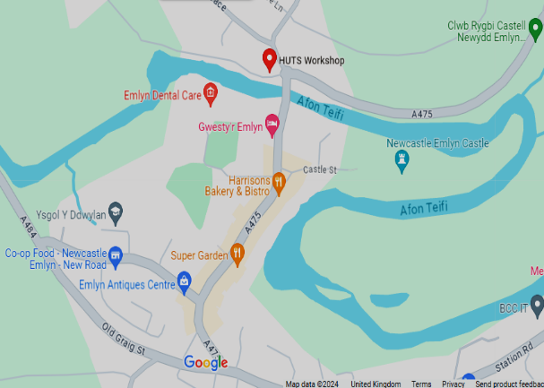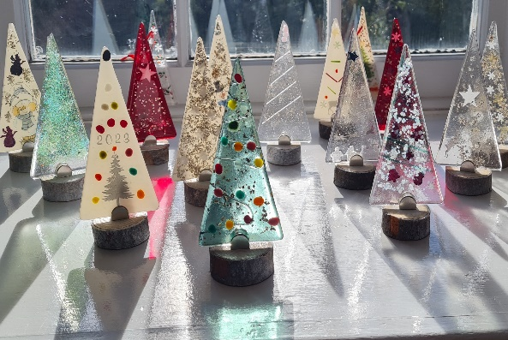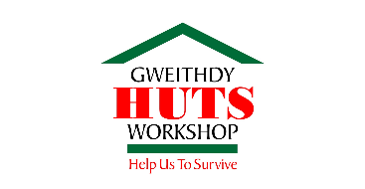FN99801-IMG06

Research bodies state that ‘The facts and figures around Mental Health in the UK are alarming’:

* One in four people will experience some kind of mental health problem in the course of a year.
* Nearly half (43.4%) of adults believe they have had a diagnosable mental health condition at some point in their life.
* 61% of adults with mental health conditions do not access treatment.
* 98% of people agree that mentally ill people experience stigma and discrimination
* 74% of adults have felt so stressed at some point over the last year they felt overwhelmed or unable to cope.
* The overwhelming majority (79%) of adults

feel stressed at least one day a month.

Find us & follow on: 

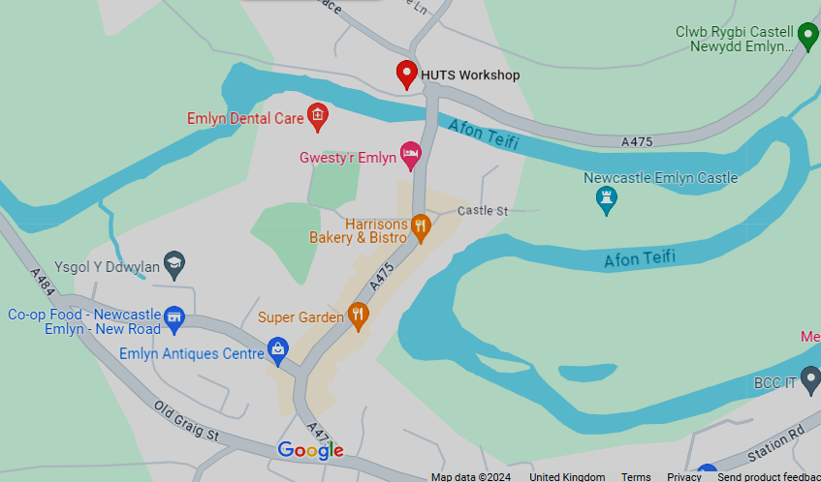

HUTS (Help Us To Survive) is a charitable organisation serving Carmarthenshire, Ceredigion and Pembrokeshire offering therapeutic arts and crafts opportunities in our workshop to those affected by mental health issues or learning difficulties. Through support and social interaction members are given space in a safe and nurturing environment to gain confidence and develop skills to assist them in the wider community.

HUTS works in partnership with the local health board and other organisations with the aim for our members to re-integrate back into the community.

Additional support is provided by Advocacy groups, the Citizen Advice Bureau and other relevant organisations.

**What does HUTS do?**

Members are encouraged to explore their creativity through artistic expression whilst receiving support with everyday problems and challenges and learning essential life skills. Our crafts include pottery, woodwork, jewellery, knitting, crochet and many more.

HUTS has been established since 1996 and has gone from two cramped and dark rooms to a wonderful renovated, fully disabled friendly building, thanks to a Big Lottery grant in 2011.

HUTS relies totally on grants and donations.

Volunteers – We are always looking for volunteers. Why not call in, have a coffee and a chat. You can give as much or as little time as you can.

Room hire available – Evenings & weekends for meetings, parties, social and community events.

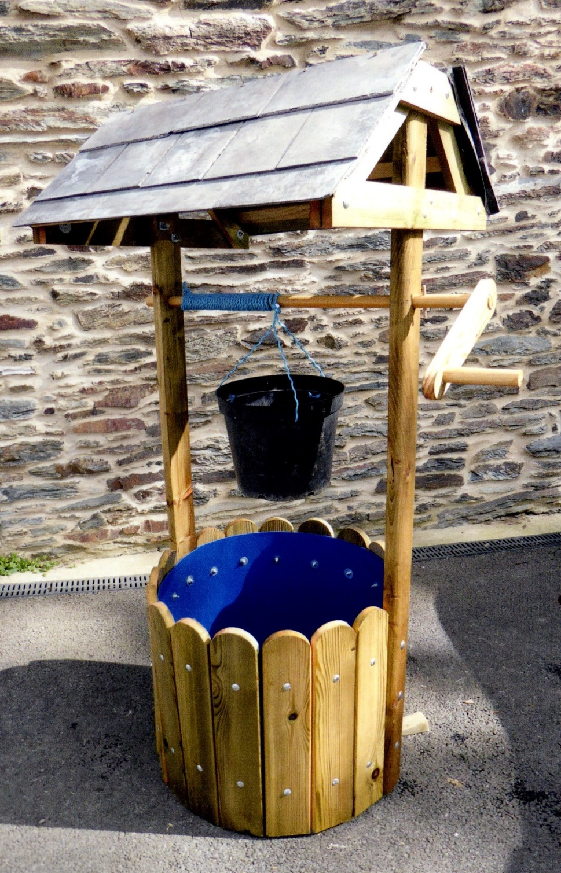

**Member’s comments:**

*HUTS has been a true lifeline for me and my wife.*

*HUTS supports me, values me and respects me.*

*HUTS has given me a new life and lifted me out of the dark hole I was in.*

*HUTS is like unconditional love. I’m not judged here.*

*Without HUTS I wouldn’t be here.*

*All images are of items made in HUTS*