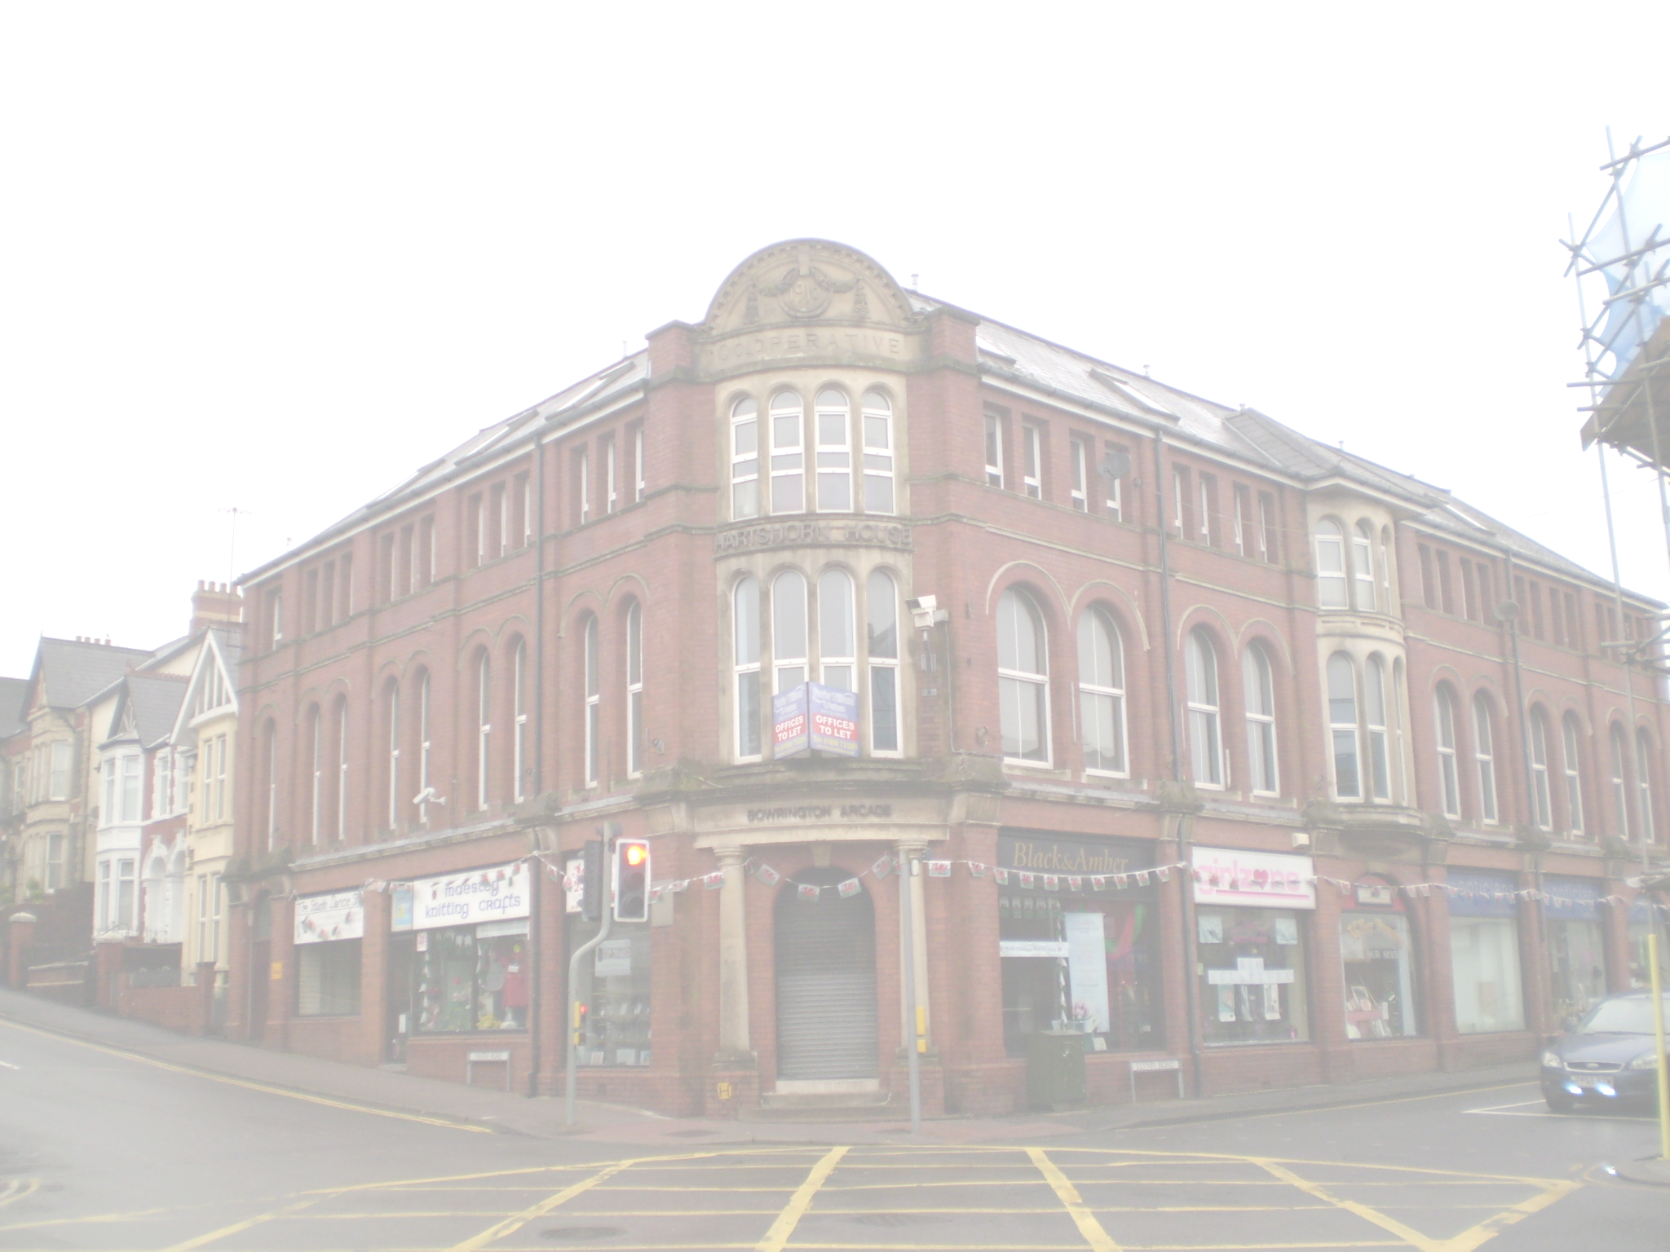  Health & Wellbeing Centre  Conveniently located in Maesteg town centre, Hartshorn House is a multi-agency base which has been developed to house health and wellbeing services for the Maesteg community and surrounding areas.  A partnership initiative between Bridgend Council, G4S and the Welsh Government; Hartshorn House has been completely renovated from what was once disused offices into a modern community hub of services which were previously only available by travelling between different locations.  Services operating within Hartshorn include help and support for substance misuse, domestic abuse, homelessness and counselling services. The centre also acts as a suitable venue for agencies to convene in its many consultation suites and office space; all of which are completely confidential. | If you would like to make an appointment with any of the services shown overleaf, please contact the service directly on their number shown.  Opening Hours:  09:00 - 17:00  Monday – Friday  If you are an organisation who may wish to use the centre please contact the Centre Manager Julie Jones: julie.jones2@uk.g4s.com  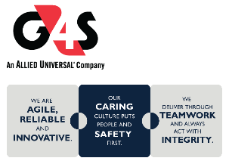  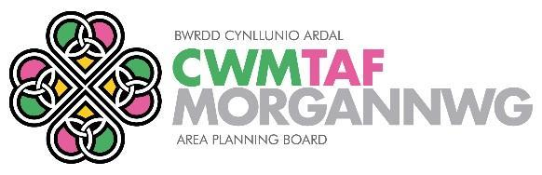  Hartshorn House Health & Wellbeing Centre  Leaflet available in Welsh | 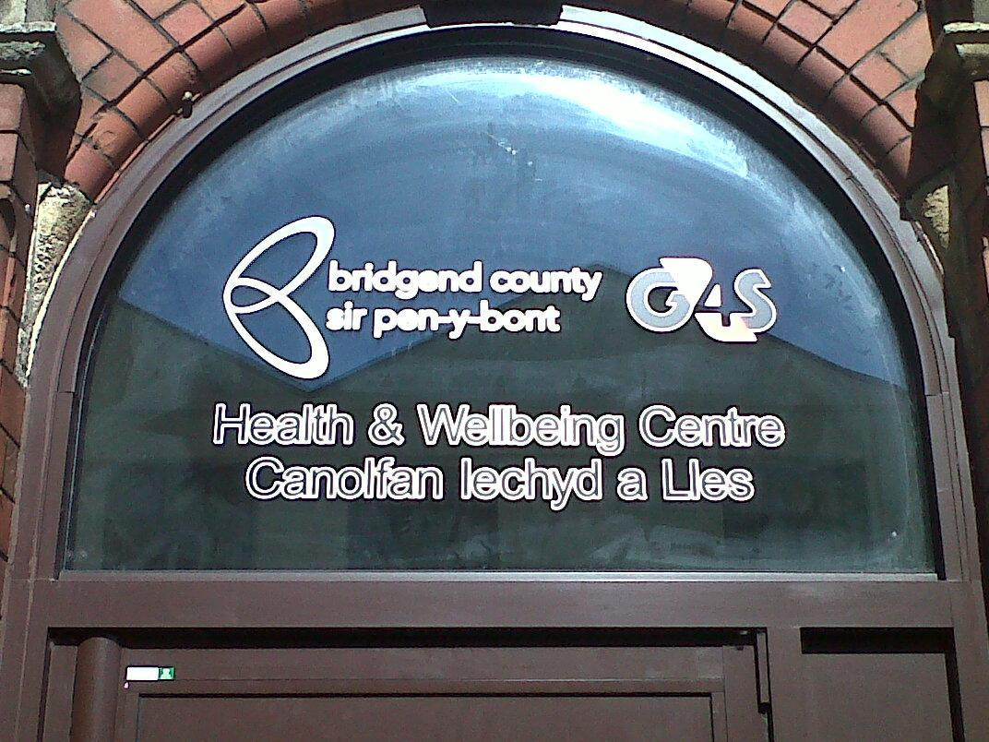  Hartshorn House  Health & Wellbeing Centre  1st Floor  Neath Road  Maesteg  CF34 9EE  Telephone: 01656 738320  Opening Hours:  09:00 - 17:00  Monday – Friday
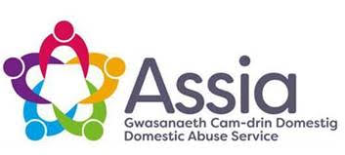
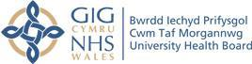
PLUS MANY MORE - Contact all organisations direct to make an appointment

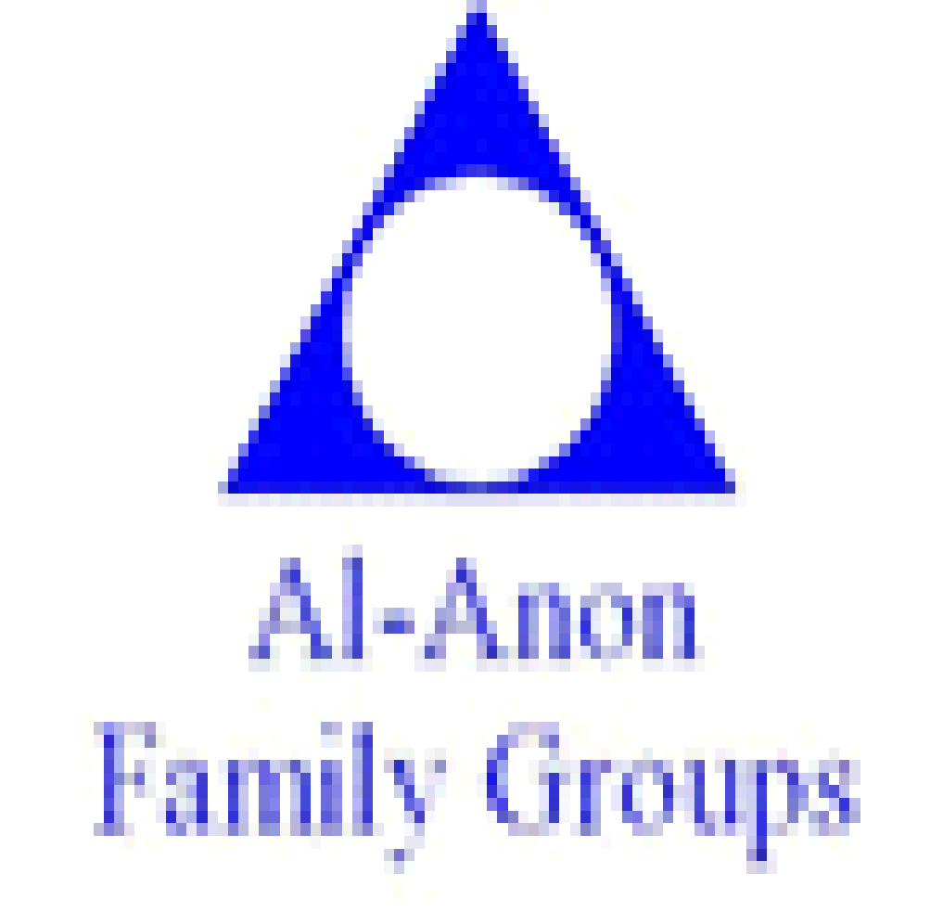

CDAT Community Drug & Alcohol Team

