Unit 14, East Gate Development, Llanelli SA15 3YF  Jobforce Wales is a Training Company which has been established for over 30 years in Llanelli and are part of the NPTC Skills Academy Wales Consortium. We deliver high-quality training within the workplace and have a Welsh Government contract to deliver NVQ (QCF) qualifications from Level 2 to 4.  There is NO COST to the employer or employee on the Apprenticeship Programme.  Training and assessment for apprenticeships currently takes place remotely and/or on the employer's premises where available (no day release needed). All evidence, assessment and feedback will be stored on the Smart Assessor e-portfolio. | Information, Advice and Guidance  Level 3 and 4  Community Development  Level 3  Management  Level 3 and 4  Team Leading  Level 2  Customer Service  Level 2 and 3  Business Administration  Level 2,3 and 4  Hospitality and Catering  Level 1,2,3  Hospitality Management  Level 4  Certificate in Food Hygiene  Level 2  Cleaning Services  Level 2  Children’s Care, Play Learning and Development  Level 2 and 3  Certificate in infection Control  Level 2  Health and Social Care  Level 2 and 3
An e-portfolio is a software-based application designed to replicate a learner’s paper-based portfolio. It allows the learner to gather and store evidence securely electronically which the Tutor, Assessor and Manager can then access remotely for a variety of purposes. Held on a secure server, an e-portfolio allows learners to interact with their own qualification and have more control over which pieces of evidence they submit and what criteria it covers. Learners will have the ability to upload information whenever they are at a computer and to store electronic evidence such as videos, sound files or photographs.

INTERESTED?

Please contact Karen Rossiter
07814000924
Krossiter@jobforcewales,org.uk

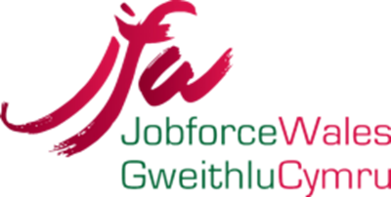

Available

Qualifications

