Landsker Quilters Workshop Programme 2018/19
Bloomfield Learning Centre Narberth
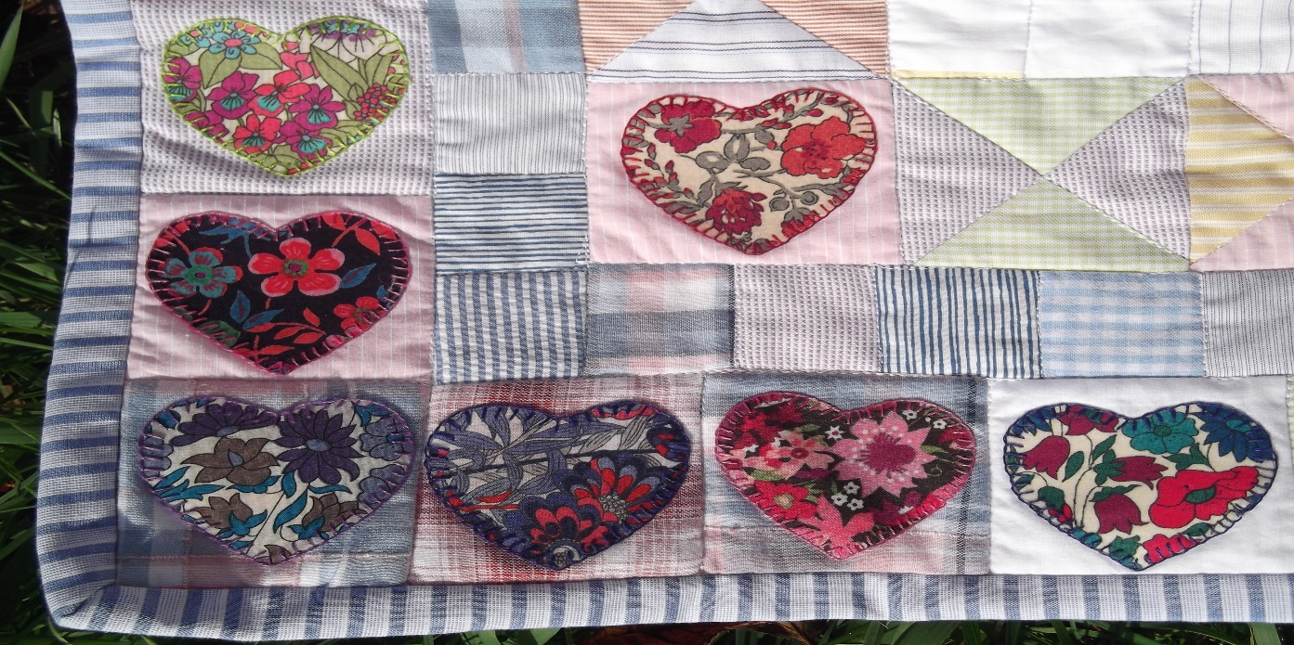
Monday 12thNov  7pm – 9pm | Foundation paper piecing | Gerda
Monday 10th December  7pm – 9pm | Applique | Judith
Monday 7th January  7pm – 9pm | Free Motion Quilting | Judy
Monday 11th Feb  7pm – 9pm | Seminole piecing | Sue G
Monday 11th March  7pm – 9pm | Scrap quilt colour choices | Sue M
Monday 8th April  7pm – 9pm | English Paper Piecing | Carlo
Monday 13th May  7pm – 9pm | Quilting with your walking foot | Sheila
Monday 10th June  7pm – 9pm | Trapunto quilting | Diane

We are always looking to welcome new members – if you would like to try a session please just call or email
- Judy Rumbelow judy.rumbelow@gmail.com 07809 560 409
- Gerda Bryant gerda.bryant@gmail.com 07785 334 213

